What is the difference between Artificial Intelligence, Machine Learning and Deep Learning?

[](https://medium.com/@juniormiranda_23768?source=post_page-----71ec27ea5a2a----------------------)

[Junior Miranda](https://medium.com/@juniormiranda_23768?source=post_page-----71ec27ea5a2a----------------------)

Follow

[Aug 20](https://medium.com/@juniormiranda_23768/what-is-the-difference-between-artificial-intelligence-machine-learning-and-deep-learning-71ec27ea5a2a?source=post_page-----71ec27ea5a2a----------------------) · 6 min read

In recent years, with the remarkable exponential growth of artificial intelligence research and applications, terms such as machine learning and deep learning have become increasingly common. Technology companies like Google, Facebook and Amazon are also investing in the area which contributes to a more active community by releasing frameworks or tools for this type of research.

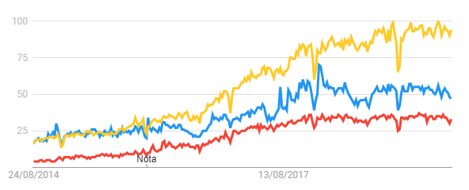

Popularity of Google Searchs from 2014 to 2019 for artificial intelligence(blue), machine learning(yellow) and deep learning(red).

It is natural that with the increasing use of technologies such as machine learning and deep learning, misunderstandings and confusion related to these terms also appear. In this article we will talk about all these terms in a top-down approach, showing where each one fits into the machine learning context and how they are subdivided.

**Artificial Intelligence**

Unlike what we see in Hollywood, Artificial Intelligence (AI) has not yet reached the point where we have robots from the future or pose a threat to humanity. Despite the somewhat “cinematic” terminology, we can define AI as the ability of machines to “mimic” some cognitive abilities of humans, such as solving problems or learning a particular activity.

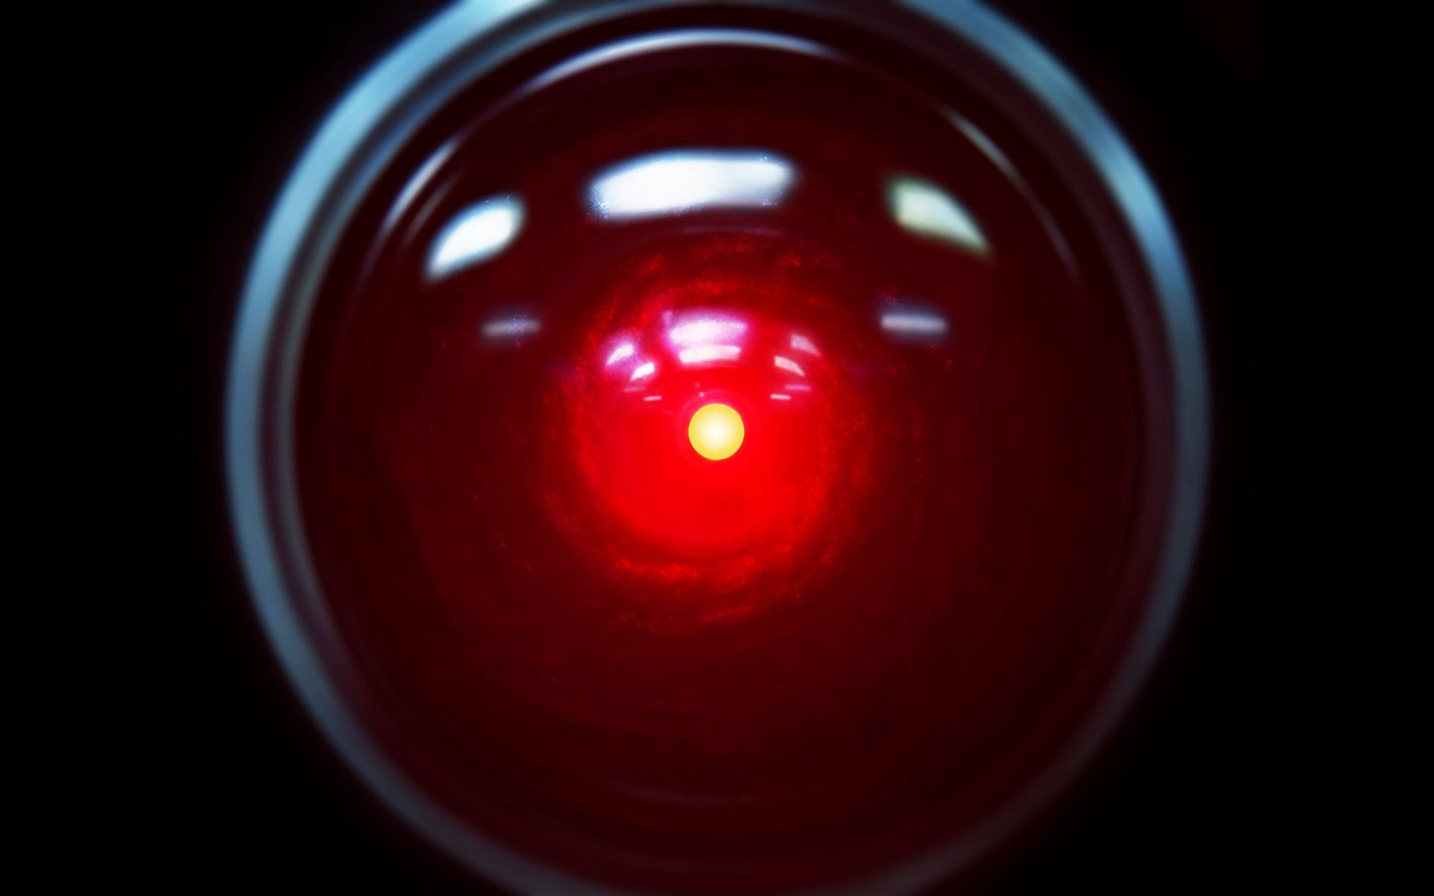

HAL 9000

AI is a very comprehensive topic and has several classes of algorithms. One such class is known as **machine learning**, which consists of statistical models that have the ability to learn from examples. One of these models is based on the human brain and is known as **neural network**s. A series of techniques that enable neural networks to solve more complex problems is called **deep learning**, as we will see in this article.

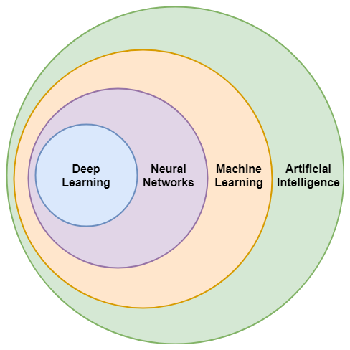

Artificial Intelligence subtopics

**Machine Learning**

We can define Machine Learning (ML) as a subset of AI where algorithms and mathematical models are used where it is not necessary to explicitly code instructions to solve a particular problem, instead we only train a model with a large number of examples, called a training set, and we hope that he will be able to generalize the knowledge gained during training so that he can perform some task. This class of AI algorithms and models can be used for classification, prediction, etc.

In some situations this approach is not necessary, but in others it would be very complex and laborious to write code to solve some problems, such as classifying whether an image is of a dog or cat or predicting the stock market. In these situations machine learning techniques are very useful.

ML still falls into a few categories according to the training set and problem we are trying to solve. These are supervised, unsupervised, semi-supervised and reinforcement learning.

**Supervised Learning**

In this type of learning, each element of the training set must consist of the desired input and output pairs for the model to be trained. In the example of the dog or cat image sorter, the training set would consist of pairs with input values, which would be the images, and output values, which would be the labels (dog/cat) of each image.

Examples for this type of learning are multilayer perceptrons, support vector machines, decision trees, naive Bayes, etc.

**Unsupervised Learning**

It is common for us to have an unlabeled data set that still has sufficient information and characteristics so that it can be grouped into classes that follow some pattern. This is the goal of unsupervised learning: to learn some pattern in the unlabeled training set and thereby be able to classify each element into particular groups. This category includes clustering algorithms such as self-organizing maps, kNN, etc.

**Semi-Supervised Learning**

A middle ground between supervised and unsupervised learning is semi-supervised. In this type of learning there is a small amount of labeled data and a large amount of unlabeled data. In this way, algorithms that use the labeled part of the data are used to guide the model to a good starting point, and then continue the training with the unlabeled data.

**Reinforcement Learning**

Reinforcement learning differs from the others shown by not necessarily being trained with a previously collected dataset, but from the interaction of an agent with an environment. The goal of the RL model is to choose a given action that maximizes the reward in a specific state. Thus, during training the algorithm will explore the environment through agent actions so that after several iterations it recognizes the best action to take for each situation. Therefore, this type of approach is generally used in autonomous vehicles, video game AI or robotics.

**Neural Networks and Deep Learning**

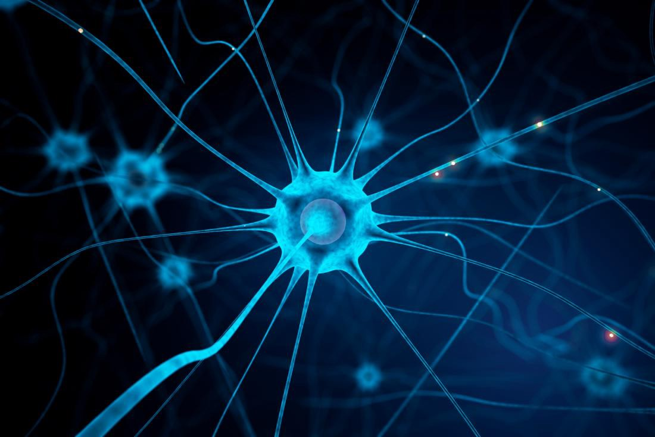

A representation of a neuron.

One type of algorithm widely used in ML is Artificial Neural Networks. This model is based on the human brain, where cells called neurons connect to other neurons, usually in layers, forming a network that can be trained through examples to accomplish a specific task.

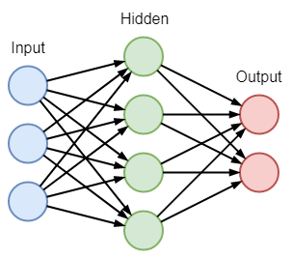

A simple neural network with an input layer(blue), a hidden layer(green) and an output(red). Each arrow connecting two neurons has a weight associated with it.

As shown in the image, each neuron has inputs and outputs, and what “in” and “out” are numeric values. Each of the input values is multiplied by weights for each connection between one neuron and another, and then these products are summed and passed by an activation function, which will be the output value of the neuron. In addition, the arrangement of layered neurons makes it possible to abstract the problem as data from the first layer, or input layer, “advances” in the network to the last layer, or output layer.

Network learning consists of adjusting the weights of the connections according to the examples shown during training, taking into account the difference between the desired and the obtained output, ie the error. To update the value of each weight it is necessary to propagate the error value from the last layer to the initial layer taking into account the error rate of change with each weight, ie the derivative or gradient. The process of updating the weights at each iteration according to the gradients is called the gradient descent. The algorithm used to obtain these gradients by string rule is called backpropagation.

However, as already mentioned, as the complexity of the problem grows, it is necessary to increase the number of layers in order to increasingly abstract the problem and make possible a solution from the model. It turns out that if we increase the number of hidden layers too much, there are problems called gradient explosion or vanishing. This is because if the gradient value is too large or too small, as it is propagated and multiplied by the various layers to the input layer, they grow or shrink indefinitely. Not to mention that for more complex problems more examples are needed for the training process.

To solve this problem, a series of strategies and methods are adopted which consist of using other activation functions in neurons, regularized loss functions and a larger amount of data in the training set. These measures that provided neural networks with more hidden layers to solve increasingly complex problems is what we know as **deep learning**.

It was deep learning that enabled significant results in image and voice recognition, natural language processing, autonomous cars, recommendation systems, among others we have seen in recent years.

**Conclusions**

As noted, AI is a topic with several subcategories, each with its own algorithms and methods. One of these, ML, has gained notoriety in recent years through an improvement in one of its models, deep learning, which has made AI closer to our cognitive abilities. It is noteworthy that to deal with the large volume of information and complexity required for deep learning models, it was also necessary hardware capable of handling these technologies, and this was one of the pillars of the success of deep learning.

With active research, an ever-growing community and hardware innovations, we can be expected to get closer and closer to an artificial intelligence increasingly similar to what already exists in nature. We are just getting started and much remains to be explored.